Clay County  Planning Commission |  | 25 Center St  Vermillion City Hall
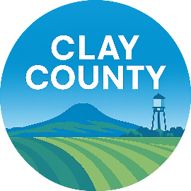

TENTATIVE AGENDA

5:30 P.M., August 10th, 2026
- Opening Items
  - Meeting Called to order
  - Roll Call
  - Approval of Agenda
  - Conflict of Interest Declaration
- Visitors to be Heard/Public Comment - For those who do not specifically appear on the agenda, no decision shall be made at this time.
- Ordinance recommendation on amending Chapter 2, Chapter 2.01 A, Boundaries of the Joint Jurisdiction
- Ordinance recommendation for amending Chapter 2, Chapter 2.01 C, Boundaries of the Joint Jurisdiction
- Adjourn

